What is a Thermocouple?
A Thermocouple is a sensor used to measure temperature. Thermocouples consist of two wire legs made from different metals. The wires legs are welded together at one end, creating a junction. This junction is where the temperature is measured. When the junction experiences a change in temperature, a voltage is created. The voltage can then be interpreted using thermocouple reference tables to calculate the temperature.
There are many types of thermocouples, each with its own unique characteristics in terms of temperature range, durability, vibration resistance, chemical resistance, and application compatibility. Type J, K, T, & E are “Base Metal” thermocouples, the most common types of thermocouples.Type R, S, and B thermocouples are “Noble Metal” thermocouples, which are used in high temperature applications (see thermocouple temperature ranges for details).
Thermocouples are used in many industrial, scientific, and OEM applications. They can be found in nearly all industrial markets: Power Generation, Oil/Gas, Pharmaceutical, BioTech, Cement, Paper & Pulp, etc. Thermocouples are also used in everyday appliances like stoves, furnaces, and toasters.
Thermocouples are typically selected because of their low cost, high temperature limits, wide temperature ranges, and durable nature.

Types of Thermocouples:
Before discussing the various types of thermocouples, it should be noted that a thermocouple is often enclosed in a protective sheath to isolate it from the local atmosphere. This protective sheath drastically reduces the effects of corrosion.
1
Type K Thermocouple (Nickel-Chromium / Nickel-Alumel): The type K is the most common type of thermocouple. It’s inexpensive, accurate, reliable, and has a wide temperature range.
Temperature Range:
- 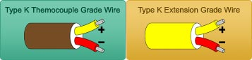Thermocouple grade wire, –454 to 2,300F (–270 to 1260C)
- Extension wire, 32 to 392F (0 to 200C)
Accuracy (whichever is greater):
- Standard: +/- 2.2C or +/- .75%
- Special Limits of Error: +/- 1.1C or 0.4%

2
Type J Thermocouple (Iron/Constantan): The type J is also very common. It has a smaller temperature range and a shorter lifespan at higher temperatures than the Type K. It is equivalent to the Type K in terms of expense and reliability.
Temperature Range:
- 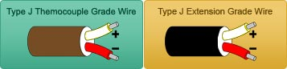Thermocouple grade wire, -346 to 1,400F (-210 to 760C)
- Extension wire, 32 to 392F (0 to 200C)
Accuracy (whichever is greater):
- Standard: +/- 2.2C or +/- .75%
- Special Limits of Error: +/- 1.1C or 0.4%

3
Type T Thermocouple (Copper/Constantan): The Type T is a very stable thermocouple and is often used in extremely low temperature applications such as cryogenics or ultra low freezers.
Temperature Range:
- 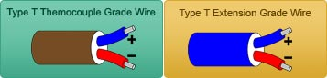Thermocouple grade wire, -454 to 700F (-270 to 370C)
- Extension wire, 32 to 392F (0 to 200C)
Accuracy (whichever is greater):
- Standard: +/- 1.0C or +/- .75%
- Special Limits of Error: +/- 0.5C or 0.4%

4
Type E Thermocouple (Nickel-Chromium/Constantan): The Type E has a stronger signal & higher accuracy than the Type K or Type J at moderate temperature ranges of 1,000F and lower. See temperature chart (linked) for details.
Temperature Range:
- 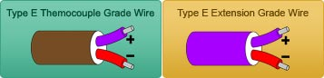Thermocouple grade wire, -454 to 1600F (-270 to 870C)
- Extension wire, 32 to 392F (0 to 200C)
Accuracy (whichever is greater):
- Standard: +/- 1.7C or +/- 0.5%
- Special Limits of Error: +/- 1.0C or 0.4%

5
Type N Thermocouple (Nicrosil / Nisil): The Type N shares the same accuracy and temperature limits as the Type K. The type N is slightly more expensive.
Temperature Range:
- 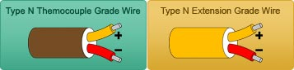 Thermocouple grade wire, -454 to 2300F (-270 to 392C)
- Extension wire, 32 to 392F (0 to 200C)
Accuracy (whichever is greater):
- Standard: +/- 2.2C or +/- .75%
- Special Limits of Error: +/- 1.1C or 0.4%
NOBLE METAL THERMOCOUPLES (Type S,R, & B):
Noble Metal Thermocouples are selected for their ability to withstand extremely high temperatures while maintaining their accuracy and lifespan. They are considerably more expensive than Base Metal Thermocouples.

6
Type S Thermocouple (Platinum Rhodium - 10% / Platinum): The Type S is used in very high temperature applications. It is commonly found in the BioTech and Pharmaceutical industries. It is sometimes used in lower temperature applications because of its high accuracy and stability.
Temperature Range:
- 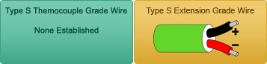Thermocouple grade wire, -58 to 2700F (-50 to 1480C)
- Extension wire, 32 to 392F (0 to 200C)
Accuracy (whichever is greater):
- Standard: +/- 1.5C or +/- .25%
- Special Limits of Error: +/- 0.6C or 0.1%

7
Type R Thermocouple (Platinum Rhodium -13% / Platinum): The Type R is used in very high temperature applications. It has a higher percentage of Rhodium than the Type S, which makes it more expensive. The Type R is very similar to the Type S in terms of performance. It is sometimes used in lower temperature applications because of its high accuracy and stability.
Temperature Range:
- 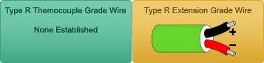Thermocouple grade wire, -58 to 2700F (-50 to 1480C)
- Extension wire, 32 to 392F (0 to 200C)
Accuracy (whichever is greater):
- Standard: +/- 1.5C or +/- .25%
- Special Limits of Error: +/- 0.6C or 0.1%

8
Type B Thermocouple (Platinum Rhodium – 30% / Platinum Rhodium – 6%): The Type B thermocouple is used in extremely high temperature applications. It has the highest temperature limit of all of the thermocouples listed above. It maintains a high level of accuracy and stability at very high temperatures.
Temperature Range:
- 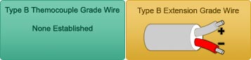Thermocouple grade wire, 32 to 3100F (0 to 1700C)
- Extension wire, 32 to 212F (0 to 100C)
Accuracy (whichever is greater):
- Standard: +/- 0.5%
- Special Limits of Error: +/- 0.25%

Thermocouple Junctions:
Grounded Thermocouples: This is the most common junction style. A thermocouple is grounded when both thermocouple wires and the sheath are all welded together to form one junction at the probe tip. Grounded thermocouples have a very good response time because the thermocouple is making direct contact with the sheath, allowing heat to transfer easily. A drawback of the grounded thermocouple is that the thermocouple is more susceptible to electrical interference. This is because the sheath often comes into contact with the surrounding area, providing a path for interference.
Ungrounded Thermocouples (Or Ungrounded Common Thermocouples): A thermocouple is ungrounded when the thermocouple wires are welded together but they are insulated from the sheath. The wires are often separated by mineral insulation.
Exposed Thermocouples (or “bare wire thermocouples”): A thermocouple is exposed when the thermocouple wires are welded together and directly inserted into the process. The response time is very quick, but exposed thermocouple wires are more prone to corrosion and degradation. Unless your application requires exposed junctions, this style is not recommended.
Ungrounded Uncommon: An ungrounded uncommon thermocouple consists of a dual thermocouple that is insulated from the sheath and each of the elements are insulated from one other.

Thermocouple Sheath Comparison:
316SS (stainless steel): This is the most common sheath material. It is relatively corrosion resistant and is cost effective.
304SS: This sheath is not as corrosion resistant as 316SS. The cost difference between 316SS and 304SS is nominal.
Inconel (registered trademark) 600: This material is recommended for highly corrosive environments.

What are Special Limits of Errors (SLE)?
Special Limits of Error: These thermocouples are made with a higher grade of thermocouple wire, which increases their accuracy. They are more expensive than standard thermocouples.
Standard Limits of Error: These thermocouples use standard “thermocouple grade” wire. They are less expensive and more common.

What is M.I. Cable?
M.I. (Mineral Insulated) cable is used to insulate thermocouple wires from one another and from the metal sheath that surrounds them. MI Cable has two (or four when duplex) thermocouple wires running down the middle of the tube. The tube is then filled with magnesium oxide powder and compacted to ensure the wires are properly insulated and separated. MI cable helps to protect the thermocouple wire from corrosion and electrical interference.

What is System Error?
System error is calculated by adding the accuracy of the temperature sensor (thermocouple) and the accuracy of the meter used to read the voltage signal together. For example, a Type K thermocouple has an accuracy of +/- 2.2C above 0C. Let’s say the meter has an accuracy of +/- 1C. That means the total system error is +/- 3.3C above 0C.

Thermocouple vs. RTD
Temperature range:
First, consider the difference in temperature ranges. Noble Metal Thermocouples can reach 3,100 F, while standard RTDs have a limit of 600 F and extended range RTDs have a limit of 1,100 F.
Accuracy, Linearity, & Stability:
As a general rule, RTDs are more accurate than thermocouples. This is especially true at lower temperature ranges. RTDs are also more stable and have better linearity than thermocouples. If accuracy, linearity, and stability are your primary concerns and your application is within an RTD’s temperature limits, go with the RTD.
Durability:
In the sensors industry, RTDs are widely regarded as a less durable sensor when compared to thermocouples. However, REOTEMP has developed manufacturing techniques that have greatly improved the durability of our RTD sensors. These techniques make REOTEMP’s RTDs nearly equivalent to thermocouples in terms of durability.
Response Time:
RTDs cannot be grounded. For this reason, they have a slower response time than grounded thermocouples. Also, thermocouples can be placed inside a smaller diameter sheath than RTDs. A smaller sheath diameter will increase response time. For example, a grounded thermocouple inside a 1/16” dia. sheath will have a faster response time than a RTD inside a ¼” dia. sheath.

